**PDC Assignment 3**

Name: Registration:

**Question#1 [5+5]**

1. Write and draw each iteration of **B= [1 2]** for **one to all broadcast** in given hypercube in form of table. What will be the minimum number of iterations required to do all to all broadcast for this network?
2. Write all the steps to be followed for **one to all scatter** operation to scatter given Array **A** in the given hypercube network which takes minimum number of iterations.

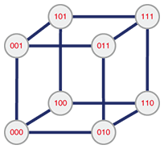A = {a, b. c. d, e, f, g, h}